Name///////////////
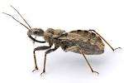_____________  change the beginning sound to /b/ | 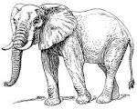  big | _____________  change the medial sound to /a/
_____________  change the medial sound to /u/ | _____________  change the beginning sound to /r/ | 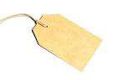_____________  change the beginning sound to /t/

